**Simulation of Building Energy Performance**

For this assignment the main objective is to analyze how the energy performance of the building can vary according to different factors like weather conditions from different cities and wall construction combinations. For the approach of this comparative analysis we use the following software: Energy Plus, Sketch up and Open Studio.

First, for the comparative analysis two different cities of Europe were chosen. The first one is Piacenza and the second NYC. Secondly, a building prototype is modeled in order to compare it in the two different scenarios. This building has a rectangular shape of 16 m x 23 m with two stories high.

The prototype for activity consists on a rectangular two-floors building for offices. The area for the whole building is 754 m2 with a height of 4 meters per floor.

For the following assignment the constructions sets (external walls) for the building were modified for trial best and worst cases for cooling and heating the entire building in a comfortable way. The construction sets combinations used for this process has these shown components (the variation is with the insulation variating from types 31, 37 and 44):

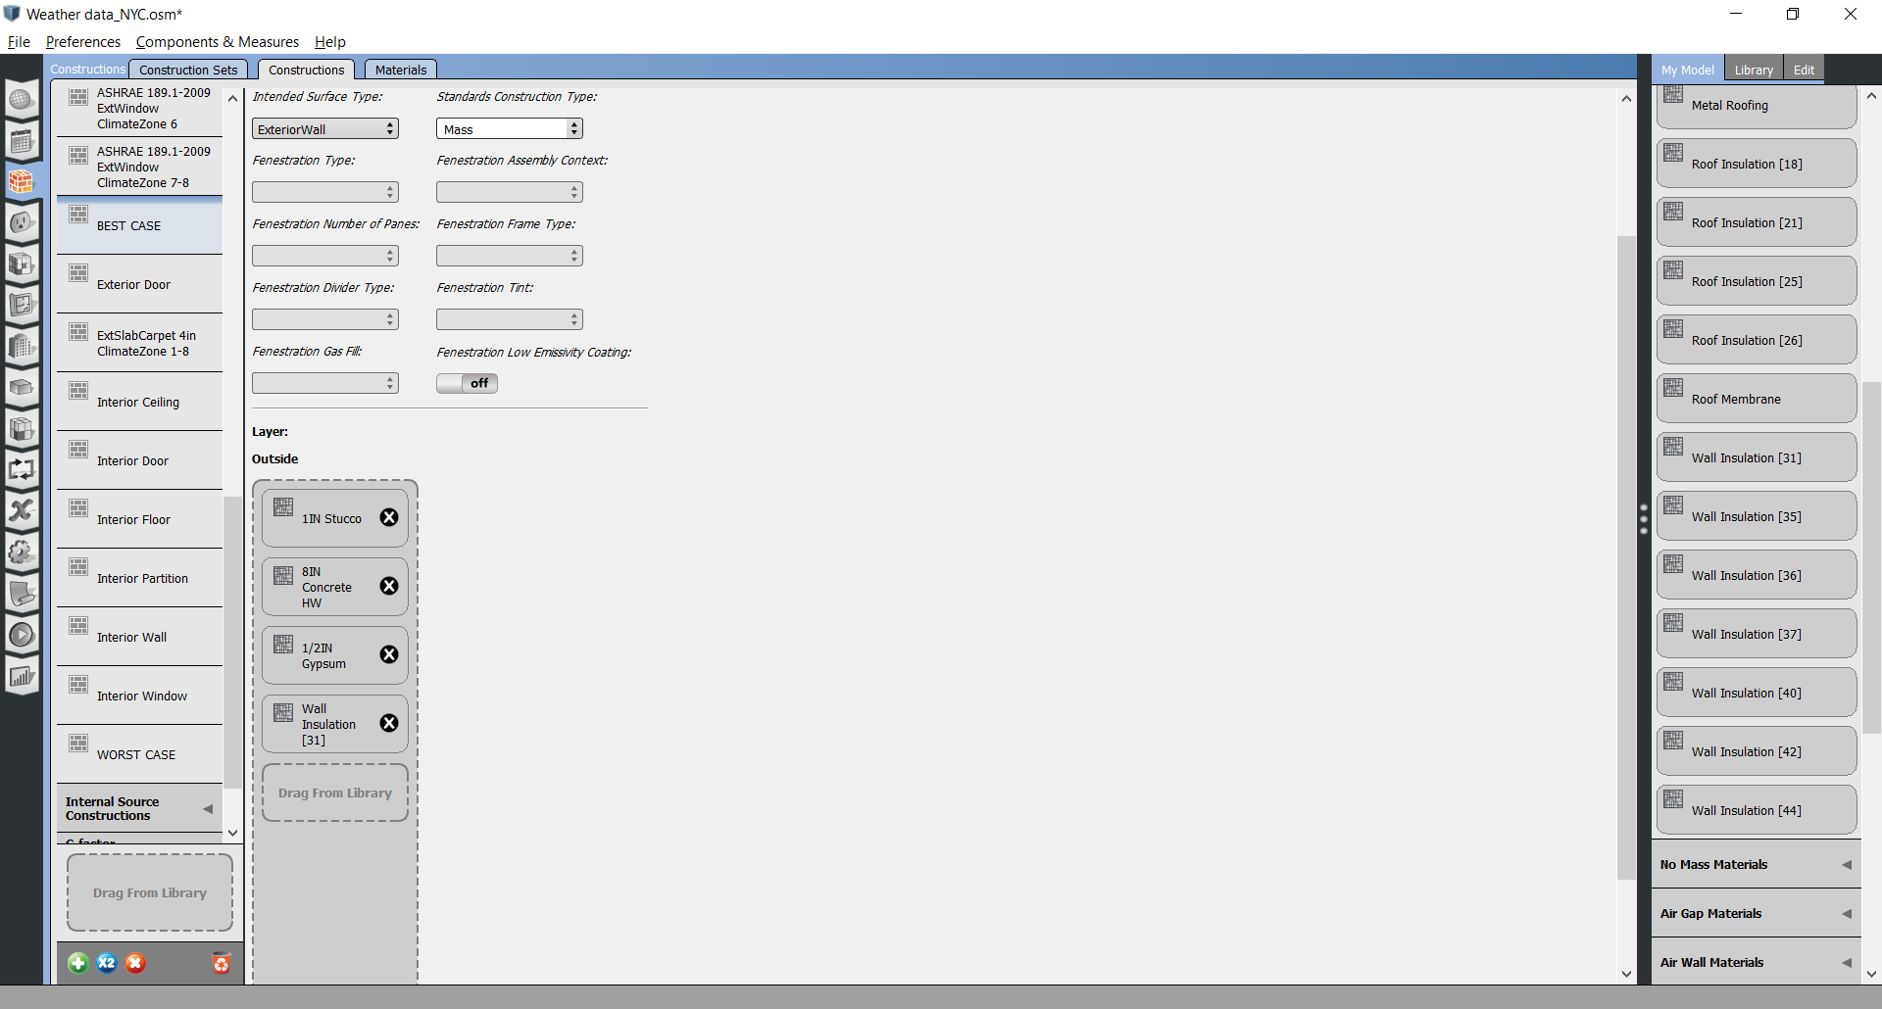

[44]

[37]

[31]

**Base Case – Piacenza**

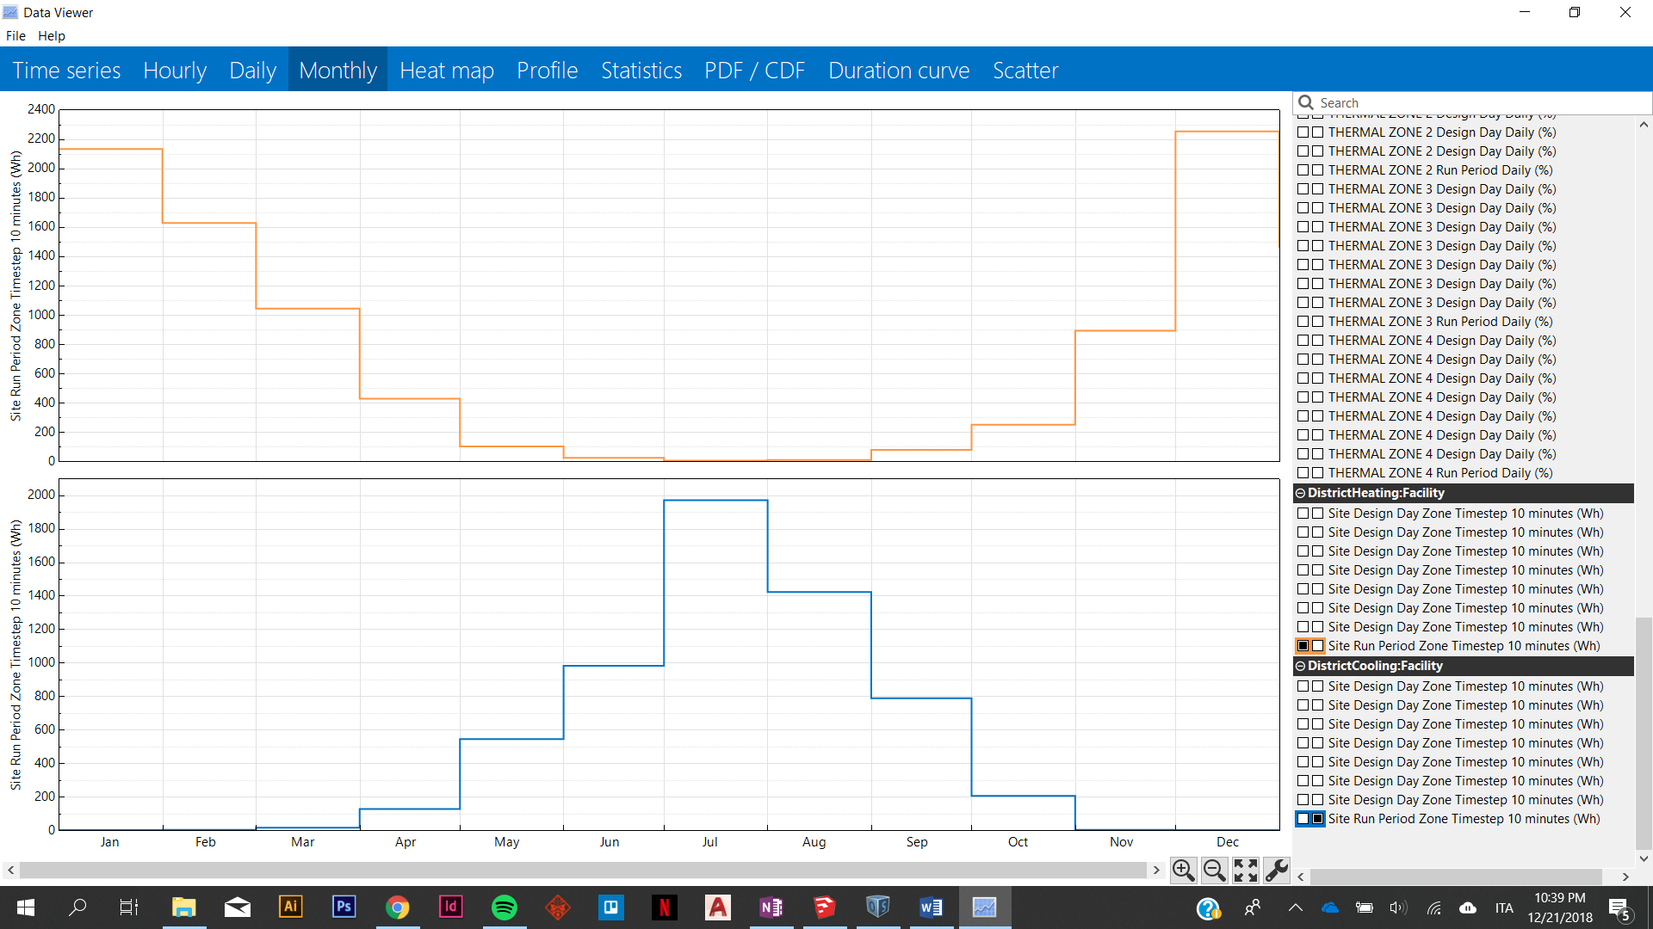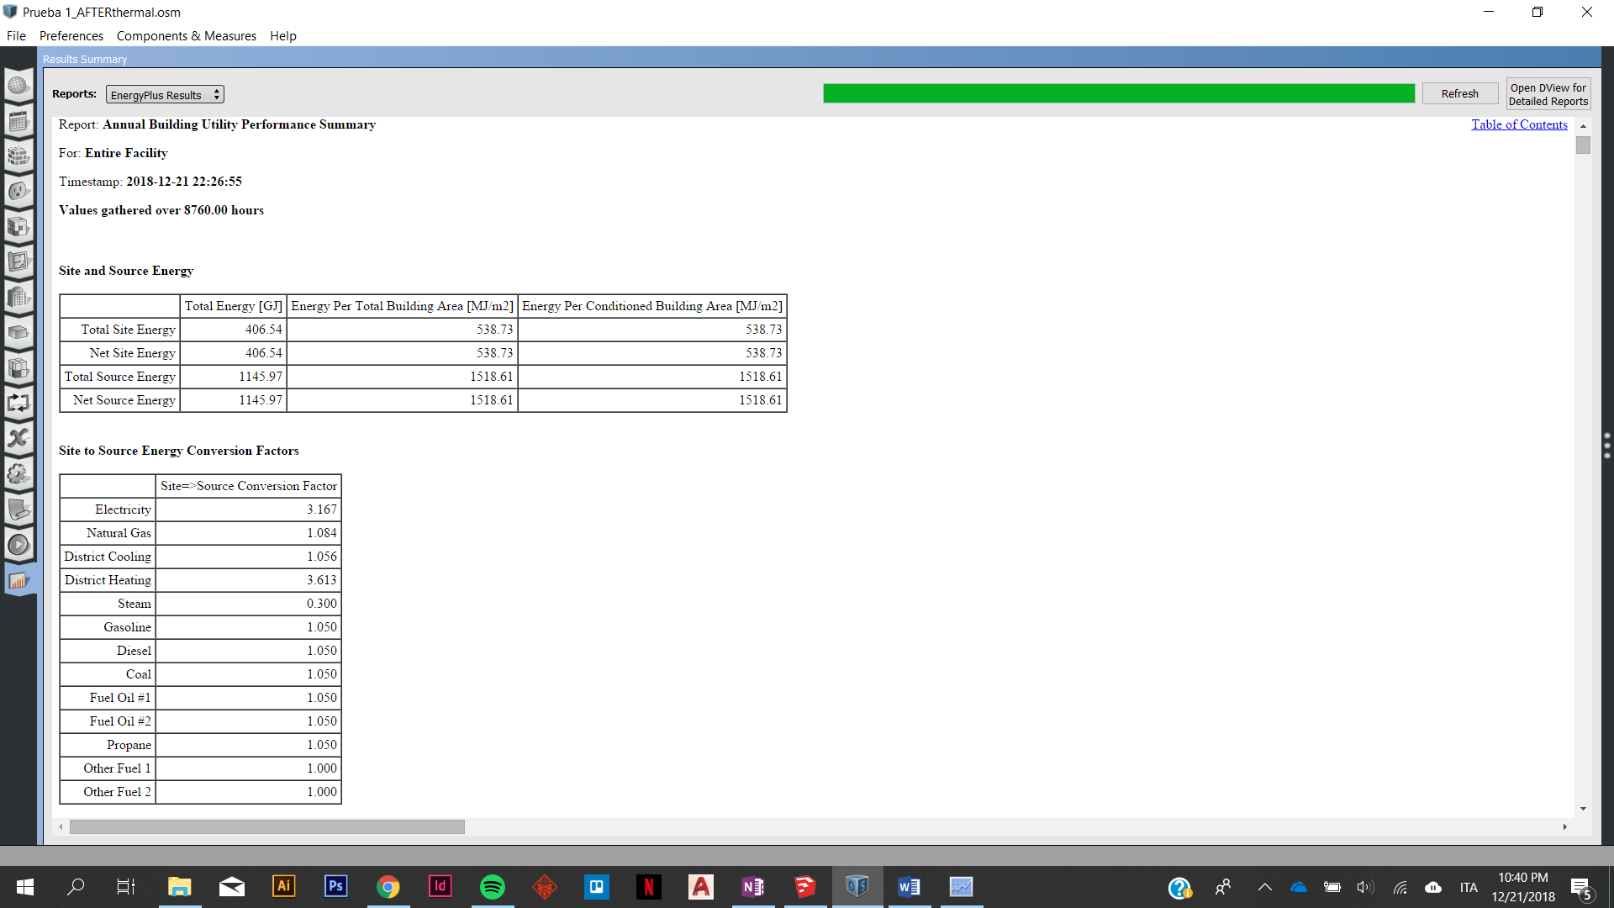

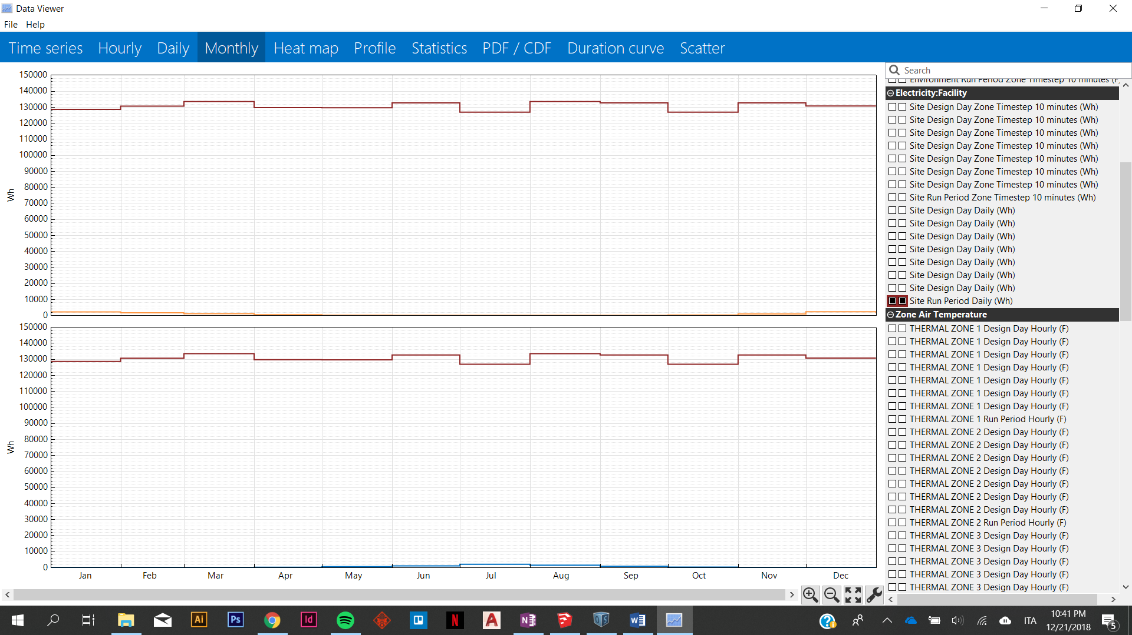

WORST SCENARIO - PIACENZA

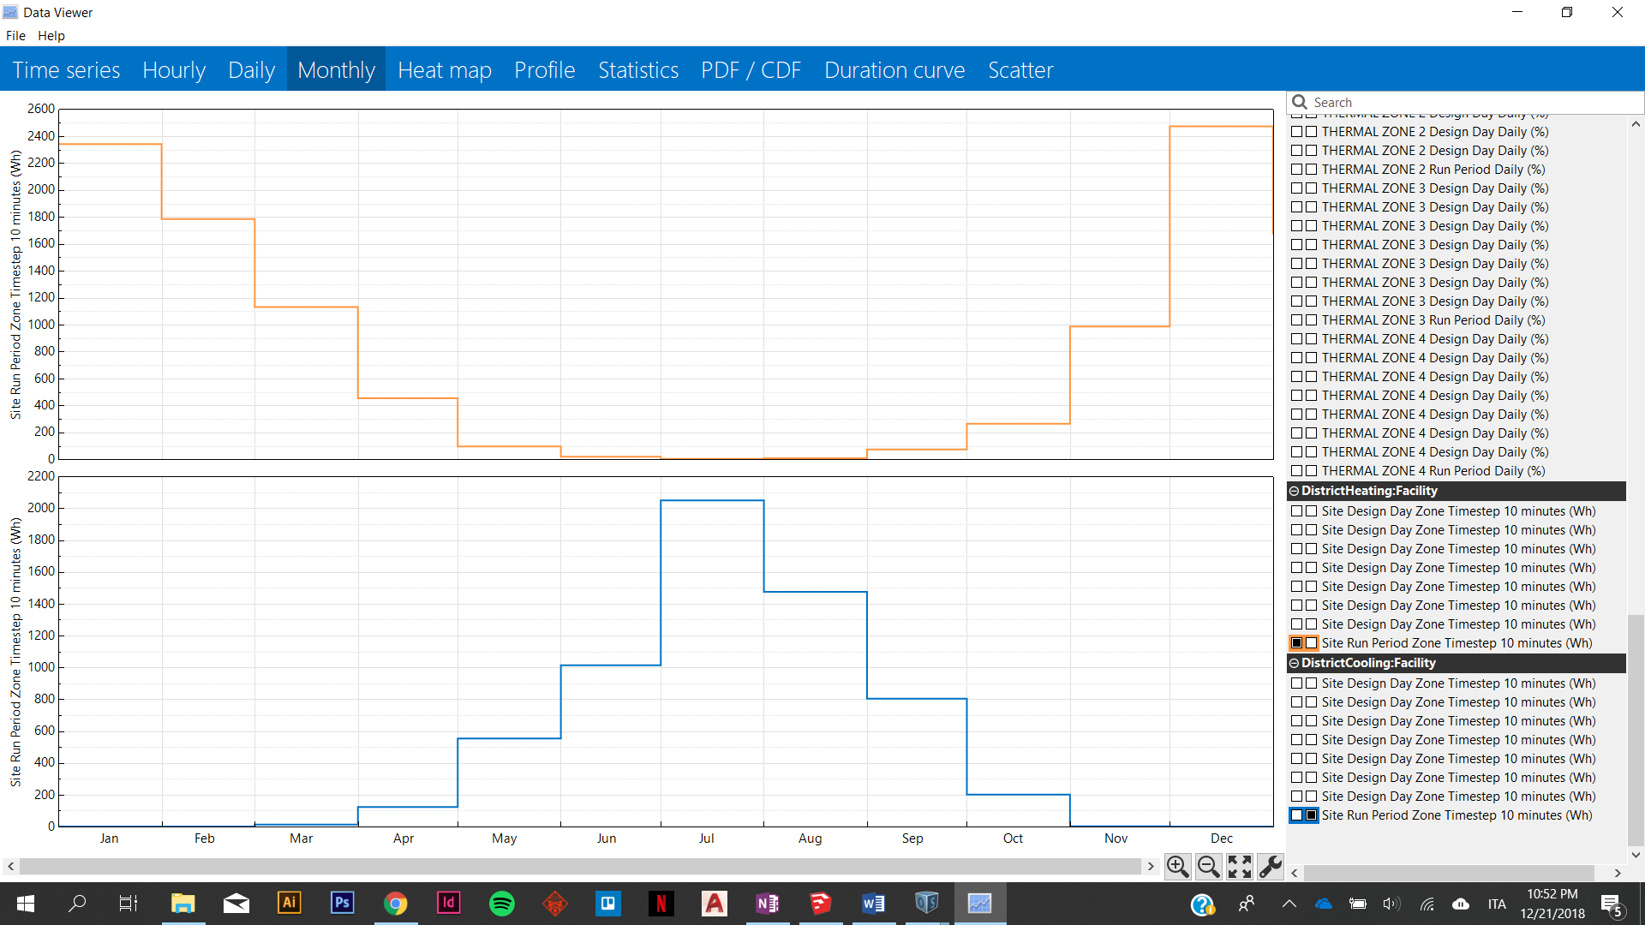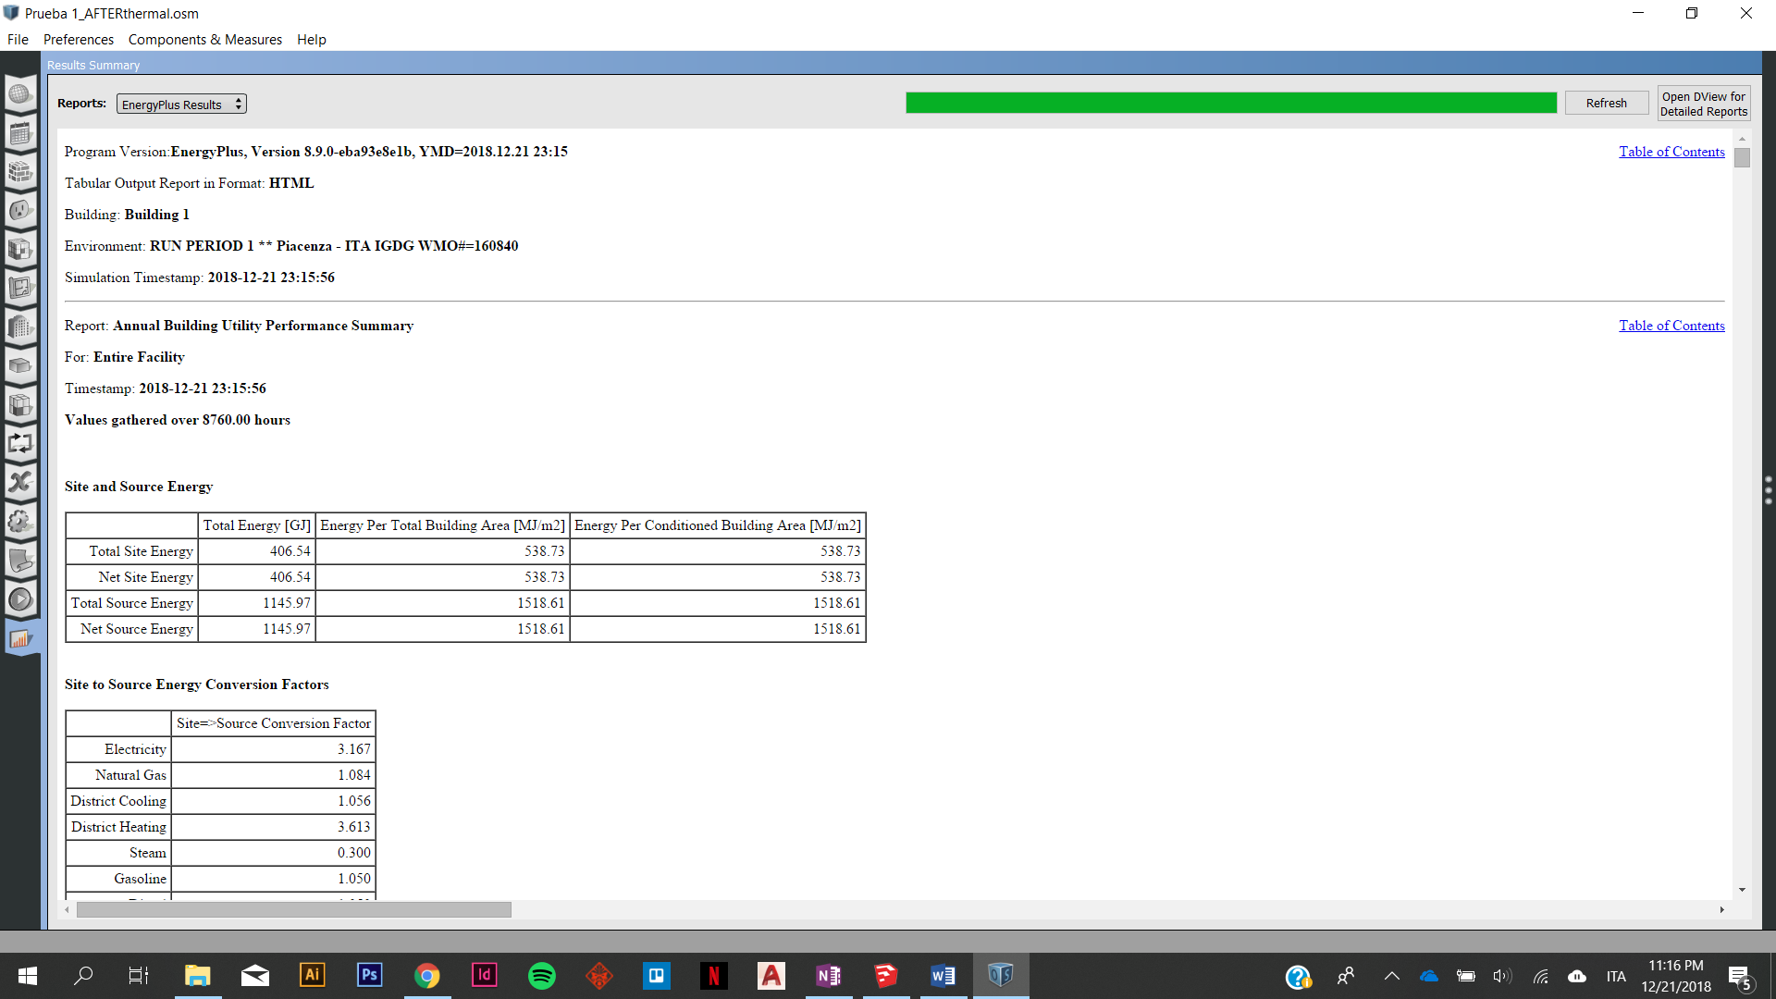

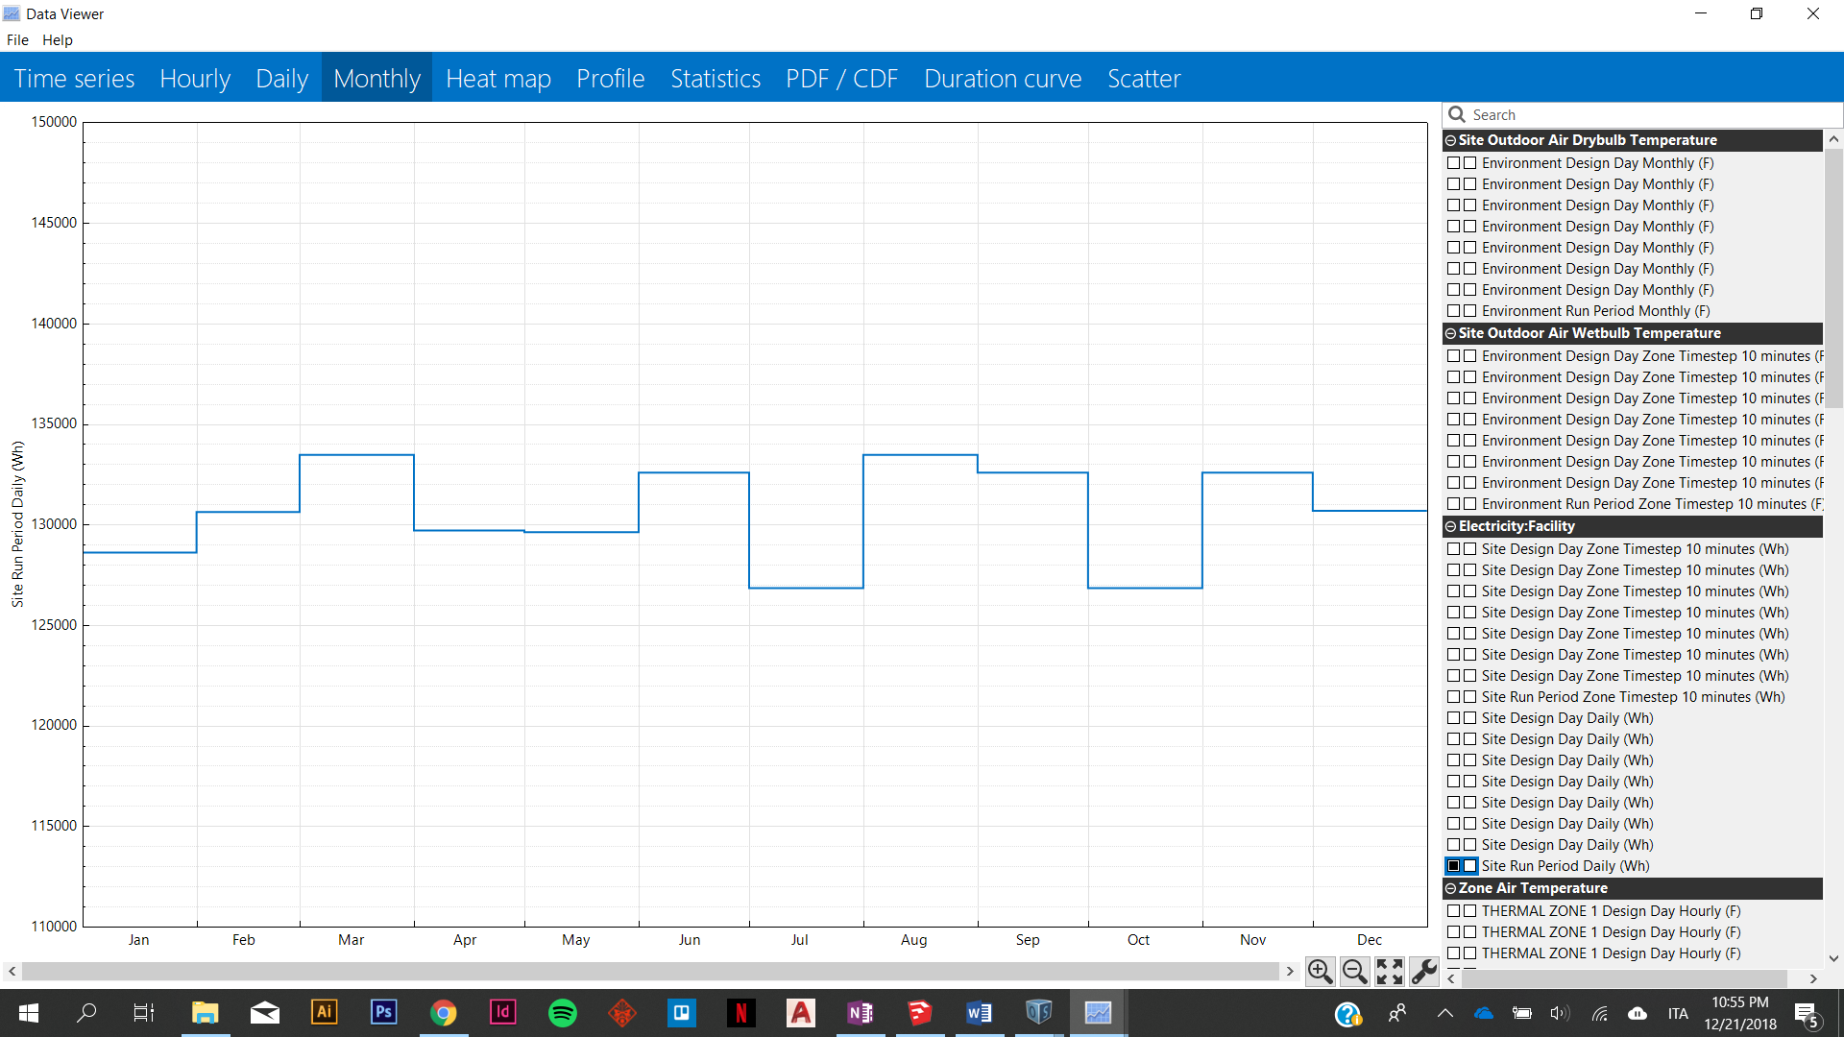

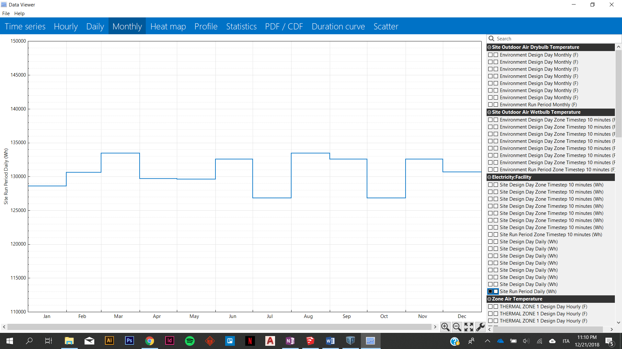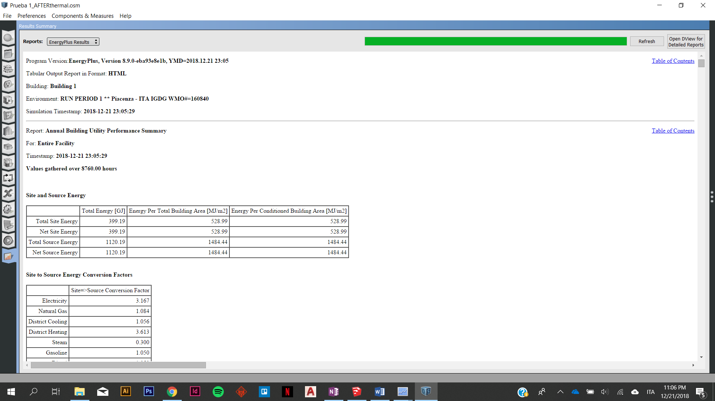BEST SCENARIO– PIACENZA

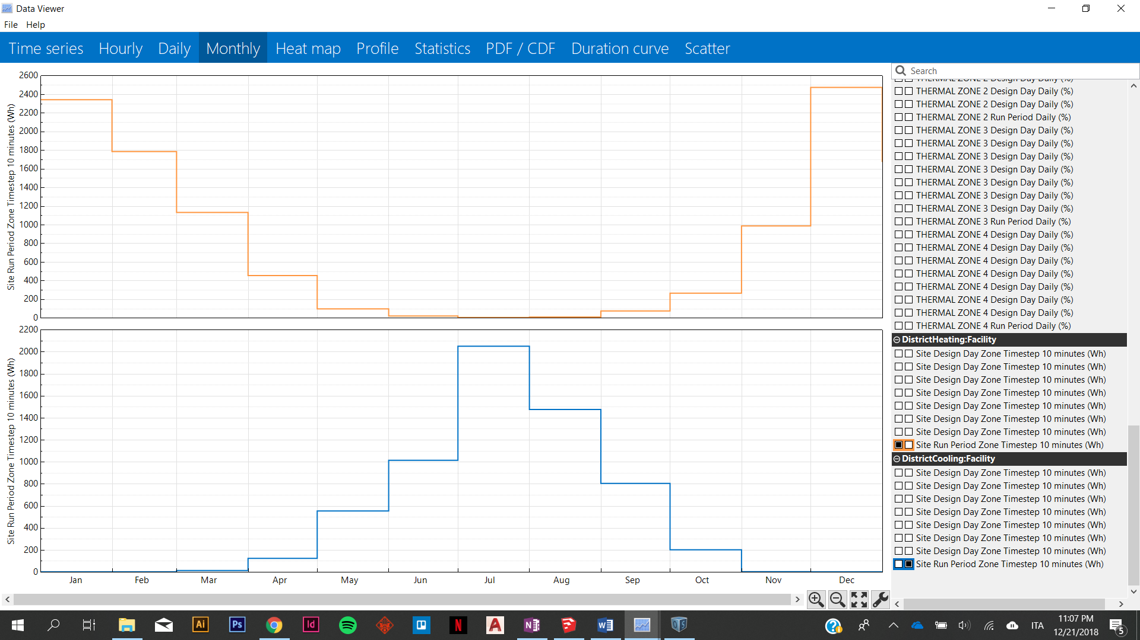

BASE CASE 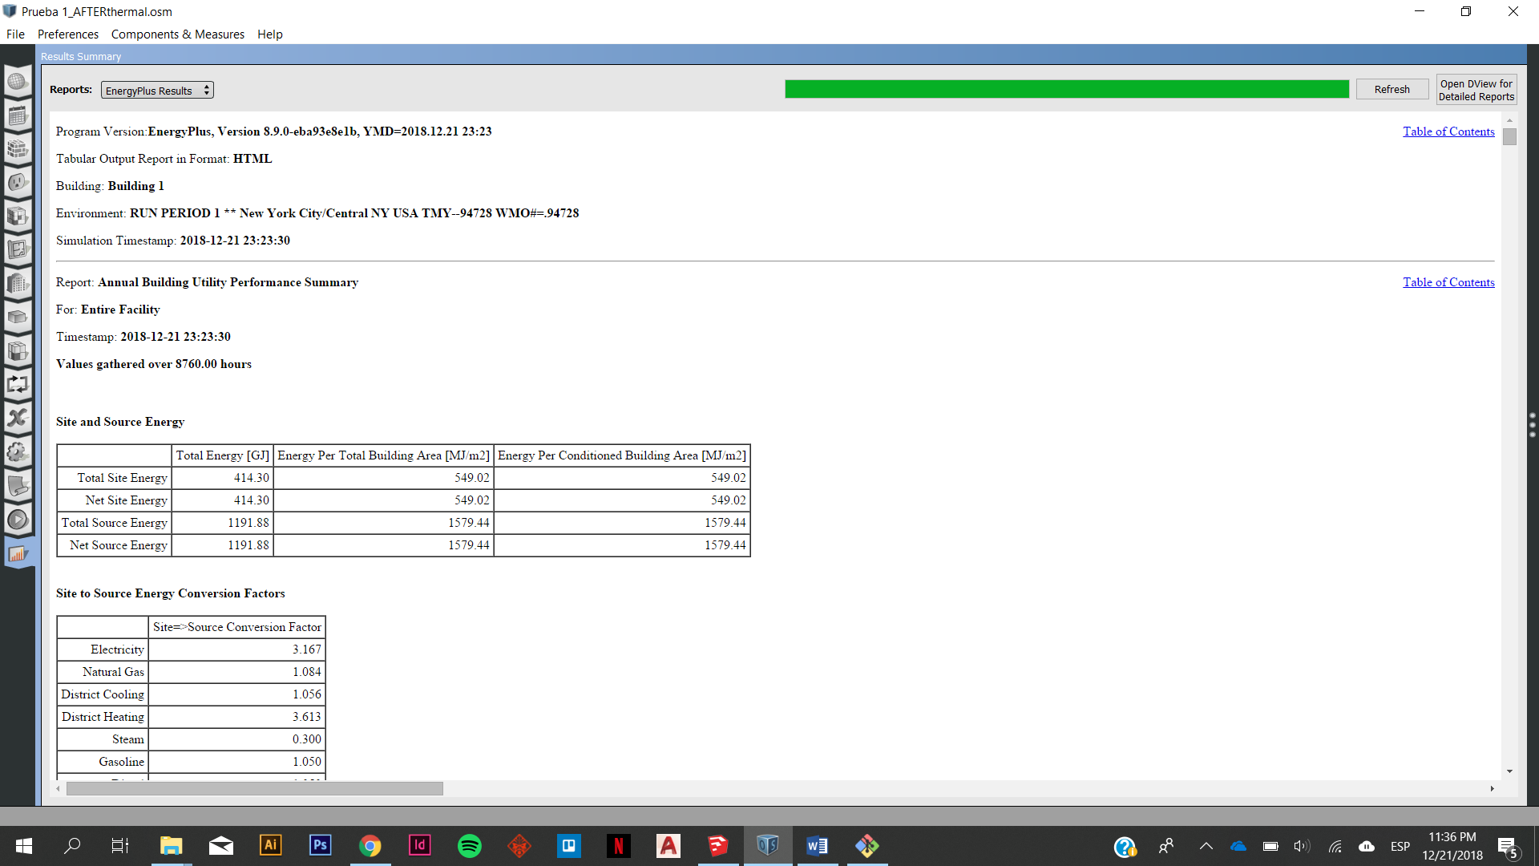 - NEW YORK

